## **MET : GONE SMALL**

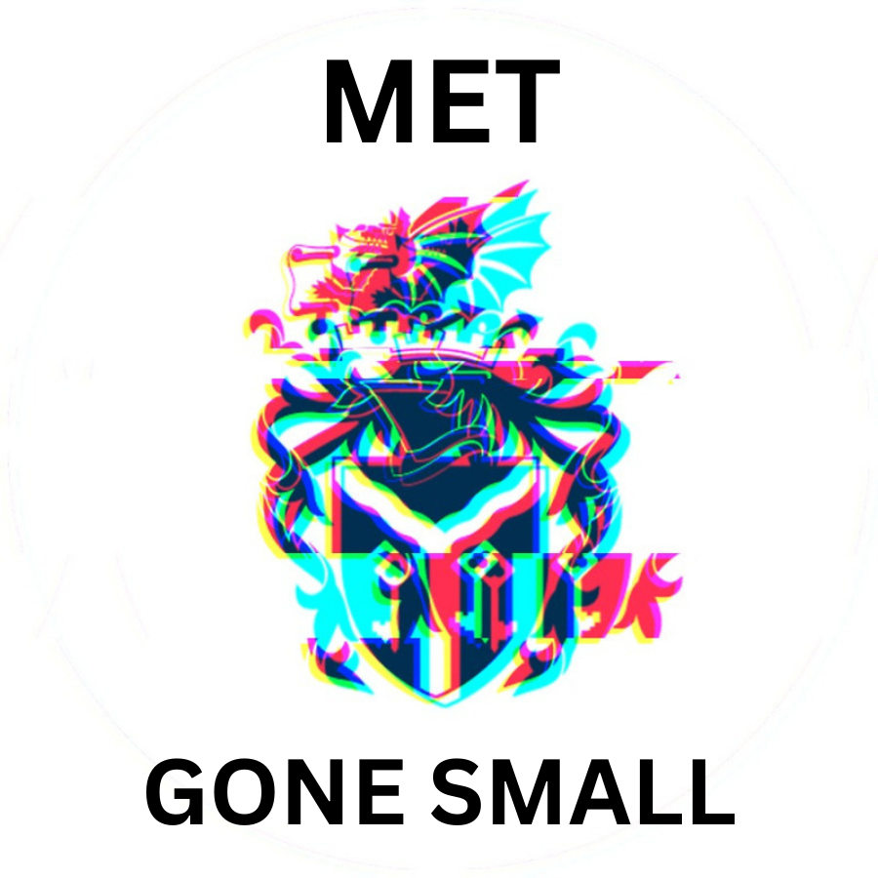  
Met: Gone Small

Document version number – v1.0

Written by: Sova Arts

Point of contact: *Liam Barrett (ST20228164@outlook.cardiffmet.ac.uk)*

Date of publishing: 15/12/23

Version number v1.0

# Table of contents

MET : GONE SMALL 1

Table of contents 1

API Versions 2

Release Version 2

Instructions 2

Repository 2

Credits 2

Other IP 3

Issue List 3

API Versions— A list of APIs and version numbers, possibly with links to an archive containing the relevant installers and any required software licence keys.

Release Version—

The release version of the game is within the Builds folder of the Unity Met: Gone Small folder, it is the Met: Gone Small.exe within. The Builds folder has all the data needed to run the game with all the assets and features.

Instructions—

To run the game:

1. Open the Met: Gone Small folder
2. Open Builds folder
3. Run Met: Gone Small application
4. Play game

Repository —

<https://github.com/Makaveli-wls/Met-GoneSmall>

Credits —

Liam Barrett - Documentation on GDD, TDD and Closing Kit, Game Sounds, All weapon code (Ammo, shooting, swapping), Health, Health and ammo UI, Death and death UI

Carl Good - Documentation on GDD and TDD, movement and orientation (walking, running, jumping,, wall jumping, wall running, reactive camera tilting), enemy model and animation, main menu screen + buttons

Rhys Allen - Documentation on GDD, TDD and Closing Kit, Enemy AI (Spawning, Chasing, Dying, Dealing Damage, Kill), Pause Menu, Level Design

Cerys Hopkins - Double jumping, sliding, health and ammo pick ups

Other IP—

No other IP was sourced for our game, as all assets and IP used were of our own

Issue List—

There is a bug with reloading weapons, this bug is caused by running out of ammo and switching before the weapon has fully reloaded then the gun will become unusable and not allow you to reload or fire anymore. We have tried multiple fixes, but the issue persists.